**Project approaches and output screenshots**

* **When manager login**

1. List of employees data with skills and profile whose status “not requested” will be displayed for current login manager and save it in useState.

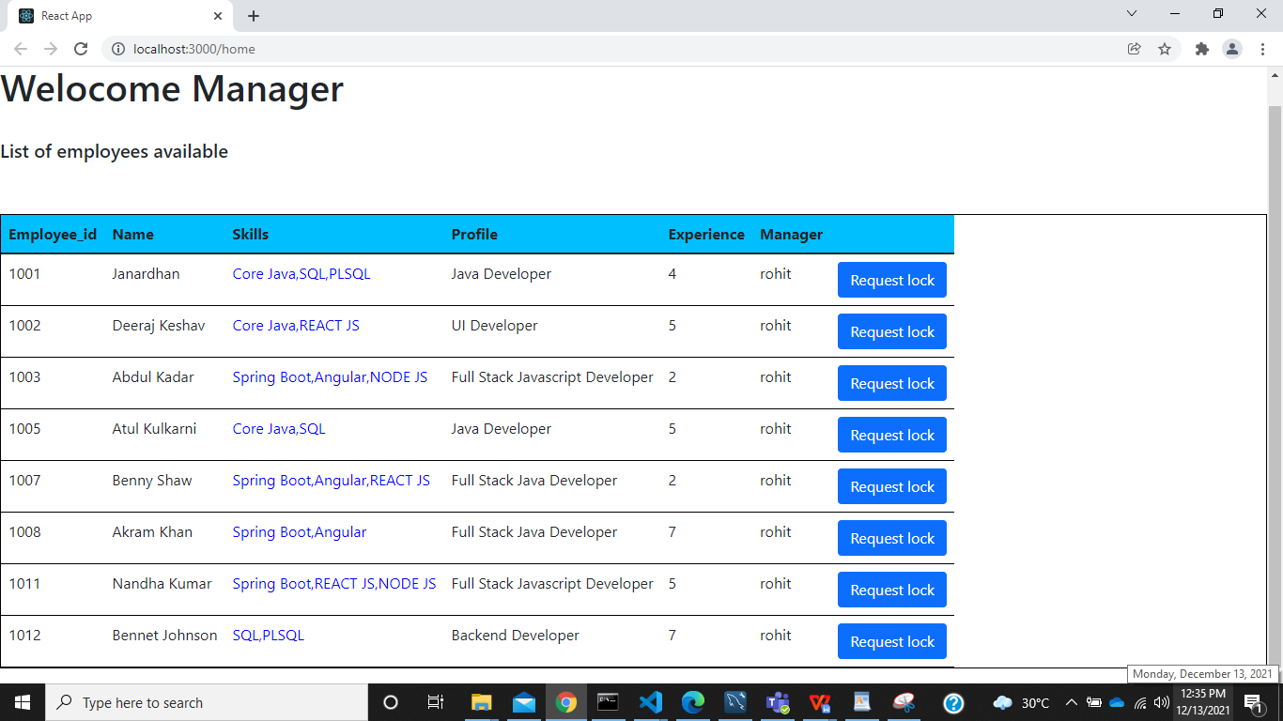

1. When Requestlock button is clicked, it will open the form which is hidden before for particular employee details with employee_id for softlock request and hide the employee table.

It ask for please confirm the lock request with selected employee_id.

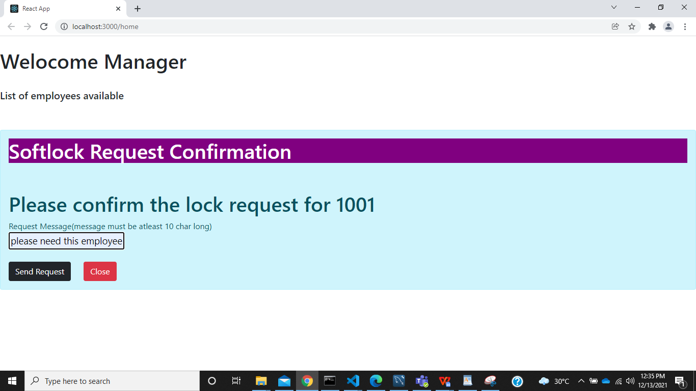

1. Here, we can type the request message and send for approval by clicking send request button. It will hit the softlock table with status as “waiting” and manager status as “awaiting_confirmation” and also set the current date automatically. And update employees table with lockstatus “request _waiting”
2. If softlock is requested, It will alert softlock Request Sended successfully or if not it will alert Not able to add the request.
3. When softlock request is sended, it will show the remaining employees data without refreshing the page.

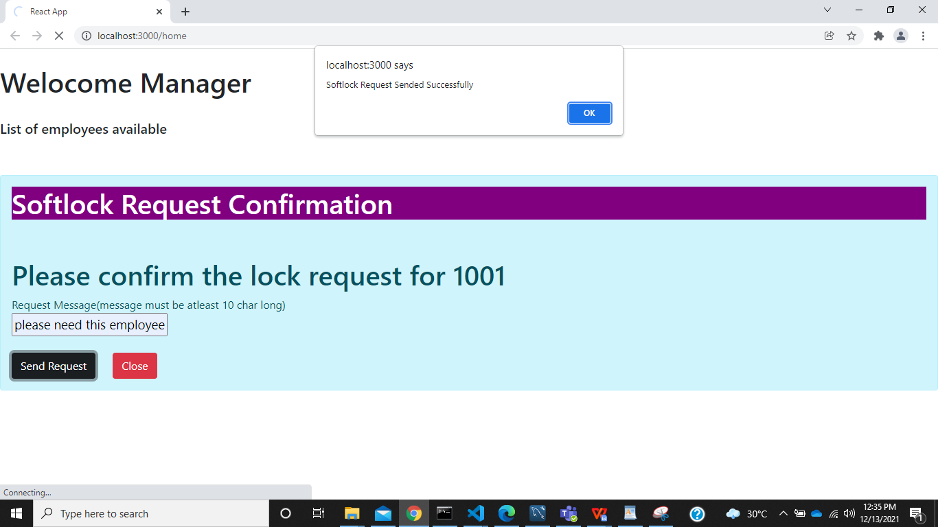

* **When wfm_manager logged in:**

1. List of employees for the current wfm_manager and whose manager status is “awaiting confirmation” , status as “waiting” and lockstatus as “request waiting” will be displayed and save it in useState.

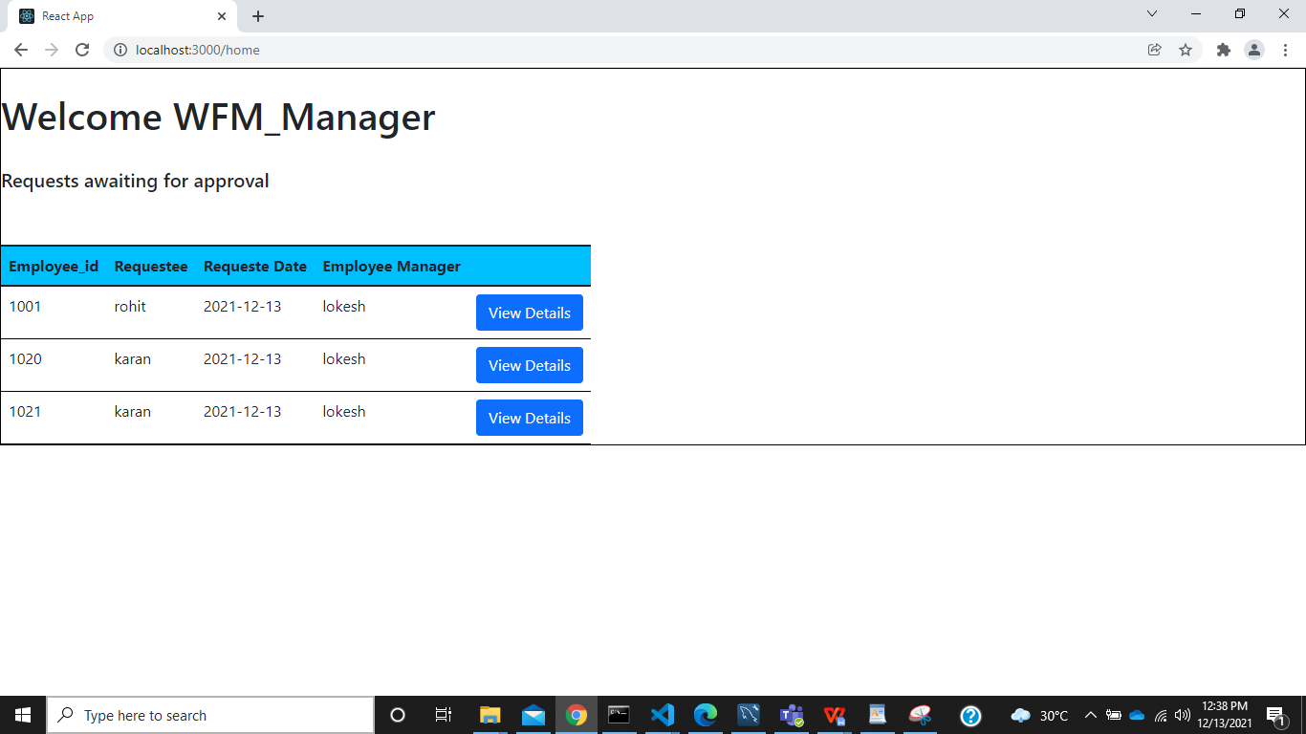

1. When view details button is clicked it will show the form which is hidden before with details of particular employee data with readonly and he can only edit status.

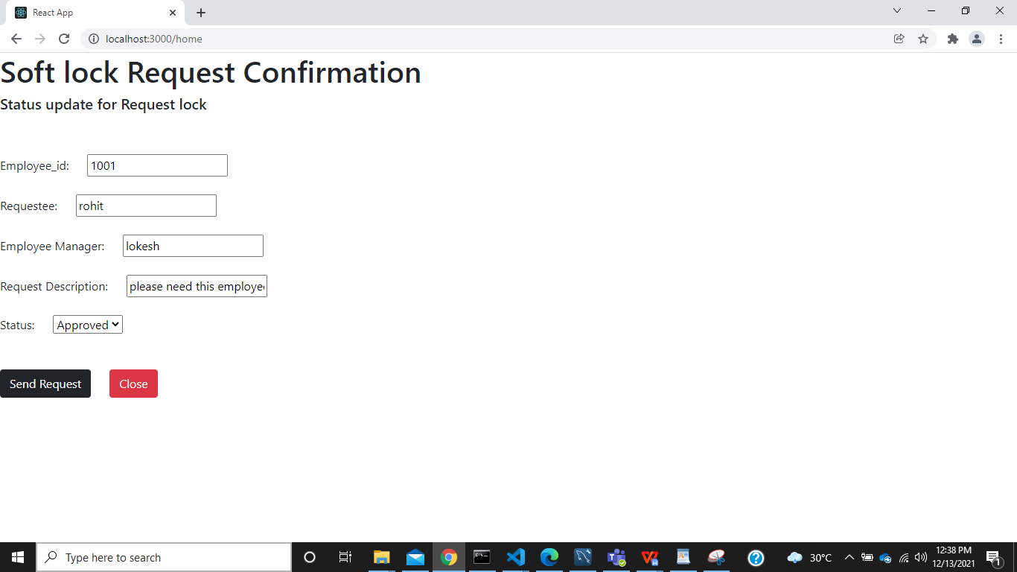

1. Here, we can update status as approval or rejected and when send button is clicked,it will alert softlock request is confirmed. And update employees table lockstatus as “locked”. Then display remaining employee requested table.
2. Or, we can click cancel button which will show the employees requested table again.

